Marmara Üniversitesi Mühendislik Fakültesi
Elektrik-Elektronik Mühendisliği

Laboratory Manual EE 3011: Electronics I
Spring 2025

Page2
TABLE OF CONTENTS

Experiment Number | Experiment Title | Page | Comments/suggestions
0 | Introductory Session. Laboratory regulations and safety rules | 3
1 | Introduction to LT Spice (part 1) | 4
2 | Introduction to LT Spice (part 2) | 7
3 | Simulation of Diode Circuits using LT Spice | 10
4 | Diode Characteristics | 16
5 | Diode Rectifiers with Peak Detector | 22
6 | MOSFET IV  Characteristics | 26
7 | The Common-source Amplifier | 31
8 | BJT IV Characteristics | 35
- | Notes and Remarks | 42

Page3
LABORATORY REGULATIONS AND SAFETY RULES
Please observe the following regulations and safety rules inside the electric circuits laboratory at all times. These rules and regulations are prescribed to safeguard all laboratory users against electrical and other hazards.
- It is your obligation to take all reasonable steps to safeguard the health and safety of yourself and other users of the laboratory. Also, equipment user is held responsible for any damage made to the equipment or other laboratory stuff, either directly or indirectly.
- Make sure that the equipment you are planning to use are in working conditions. Immediately report any defective equipment/devices to the laboratory instructor/staff.
- Use only the equipment provided in the experiment equipment list. If needed, ask the laboratory instructor for assistance.
- Make sure to energize the power supply units in your circuits in the presence of the laboratory instructor.
- Keep a safety distance between your working spot and any circuit breakers or any moving parts during the experiment.
- Avoid making contact with energized circuits. A path to ground through your body can endanger your life.
- After the completion of any experiment, make sure to switch off all equipment and disconnect the power supply units from the circuit before leaving the laboratory.
- Observe tidiness and cleanliness and proper laboratory housekeeping of the equipment and other related accessories, including wires, cables, components, integrated circuits, etc. It is forbidden to make any writing and all kinds of marking on the equipment and the working place.
- Pay a special attention to your clothing. Clothes with loose parts and/or poor protection should be avoided in the laboratory.
- Before switching on the power supply unit, make sure you double-check the circuit connections.
- Make sure that the last connection to be made in your circuit is the power supply and first thing to be disconnected is also the power supply.
- Do not remove, transfer or relocate any laboratory equipment or other accessories without permission from the laboratory instructor/staff.
- Make sure you have adequate training/orientation on a certain equipment prior to using it.
- Smoking, drinks and food are not permitted in the laboratory.

Experiment (1)
Page4
Introduction to LTspice (Part 1)

Objectives
  - To simulate simple passive circuits using DC and Transient analysis.
  - To be able to generate LTspice results using plots for various circuit variables.

Pre-lab Work
Before starting this experiment, you need to study the document “Introduction to LTspice IV with Examples”, by Nicholas Lombardo, Linear Technology, 2015.

Circuits
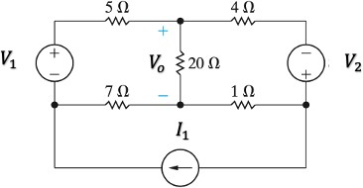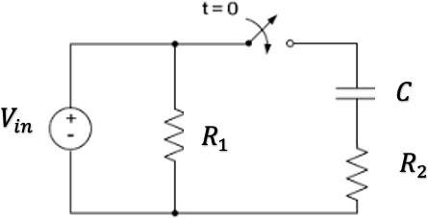
Figure 1: A DC circuit. Figure 2: Transient circuit.

Procedure
Part (1): DC Analysis.
- Connect the circuit in figure 1. Use the voltage and current sources values given by the lab instructor.
- Using simulation, find the DC voltages and currents for all resistors. Record results in table 1.
- Now make source 𝑉₁ as a variable voltage source and use the DC Sweep function to produce the transfer function curve 𝑉_{𝑜} versus 𝑉₁.
Part (2): Transient Analysis.
- Connect the circuit in figure 2. Use the circuit elements values given by the lab instructor. Set
𝑉_{𝑖𝑛} as a periodic rectangular signal with frequency 𝑓 and maximum amplitude 𝑉_{𝑚𝑎𝑥}. The switch is initially closed.
- Simulate the steady-state response of the circuit. Produce the steady-state voltage waveforms (versus time) across the capacitor 𝐶 and the resistor 𝑅₂. Put these curves together with the 𝑉_{𝑖𝑛} curve on the same plot.
- Now, as the switch is opened at 𝑡=0, simulate the circuit using the Transient analysis function and generate the voltage waveform (versus time) across the capacitor 𝐶 and the resistor 𝑅₂.

Put these curves together with the 𝑉_{𝑖𝑛} curve on the same plot. Also observe the waveform of the current through 𝑅₂. From the curves, find the time constant of the circuit.
Page5
- Change the value of 𝑓 and repeat step 3.
frekansı değiştir, v ın içinde time kısmında mesela 10m yap

Results and Analysis
Part (1): DC Analysis.

Table 1. DC Simulations in Part (1).

𝑉₁ = 𝑉₂ = 𝐼₁ =  1V 2V 1A | Simulation  -3.250 V  -2.56 V  -360.01 mV  -360.01 mA  -640 mA | Calculation | % Difference
Voltage across 1 Ω resitor
Current through 1 Ω resitor
Voltage across 4 Ω resitor
Current through 4 Ω resitor
Voltage across 5 Ω resitor
Current through 5 Ω resitor
Voltage across 7 Ω resitor
-350 mA
-2.45 V
-650 mA
Current through 7 Ω resitor
Voltage across 20 Ω resitor
-200 mV
-10 mA
Current through 20 Ω resitor

- Comment on the difference between simulation and theoretical values in table 1.

Page6
Part (2): Transient Analysis.

Table 2. Transient Simulations in Part (2).

𝑅₁ = 𝑅₂ = 𝐶 =  100 10k 1mikrof (u) | Simulation | Calculation | % Difference
Circuit time constant
- Comment on the difference between simulation and theoretical values in table 2.

- State your observations on the simulated behavior of the given RC circuit, including the effect of changing the input frequency.

Objectives

Experiment (2) Introduction to LT Spice (Part 2)

  - To simulate a first-order low-pass filter circuit using AC analysis.
Page7
  - To be able to present results using plots for various circuit variables.

Pre-lab Work
- Before starting this experiment, you need to study the document “Introduction to LT Spice IV with Examples”, by Nicholas Lombardo, Linear Technology, 2015.
- Analyze the circuit in figure 1. In particular, find the frequency response of the transfer function and filter bandwidth.

Circuits
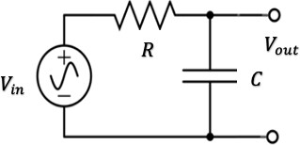
Figure 1: RC low-pass filter.

Procedure
Part (1): AC Analysis.
- Connect the circuit in figure 1. Use the circuit elements values given by the lab instructor. 𝑉_{𝑖𝑛}
is a sinusoidal AC voltage source with frequency 𝑓 and maximum amplitude 𝑉_{𝑚𝑎𝑥}.
- Simulate the circuit using the AC analysis function and generate the transfer function spectrum curve (versus frequency). Use dB scale for the transfer function magnitude and log scale for the frequency.
- Change the value of 𝐶 and observe the simulation curves.

Results and Analysis
Part (1): AC Analysis.
- From your simulations, find the simulated bandwidth of the filter for different values of 𝐶. Record your results in table 1.

Page8

Table 1. Simulated and calculated bandwidth.

Capacitor value | Simulated Bandwidth | Theoretical Bandwidth | % Difference

- Comment on the results in table 1.

- If the output of the circuit is taken across the resistor instead of the capacitor, what kind of a filter is obtained? Explain your answer and support it using simulation results.

Page9

Lab Assignment
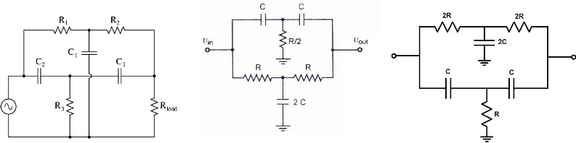

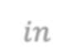
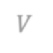



𝑉𝑖𝑛
𝑉𝑖𝑛
𝑉𝑜𝑢𝑡
𝑉𝑖𝑛
R₄
𝑉𝑜𝑢𝑡
𝑉𝑜𝑢𝑡

Circuit 1 Circuit 2 Circuit 3

- The lab instructor will assign one circuit to you with appropriate elements values.
- Connect the circuit using the circuit elements values given by the lab instructor. 𝑉_{𝑖𝑛} is a sinusoidal AC voltage source with frequency 𝑓 and maximum amplitude 𝑉_{𝑚𝑎𝑥}.
- Simulate the circuit using the AC analysis function and generate the transfer function spectrum curve (versus frequency). Use dB scale for the transfer function and log scale for the frequency.
- From your simulations, find the simulated bandwidth of this filter circuit.
- Change the value of the circuit elements (one at a time) and observe the simulation curves. Write your conclusions regarding the effect of these elements on the circuit bandwidth. Can you come-up with a formula for the bandwidth in terms of 𝐶 and 𝑅?
- What kind of a filter is this circuit? Explain.

Objectives

Experiment (3)
Simulation of Diode Circuits using LTspice

  - To study the IV characteristics of a standard diode (1N4001) by simulation.
Page10
  - To simulate simple DC and AC diode circuits.

Pre-lab Work
Analyze the circuits below using the constant voltage diode model (𝑉_{𝐷0}=0.7 V).

Circuits
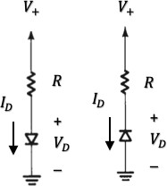
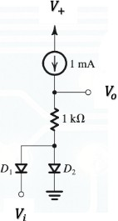

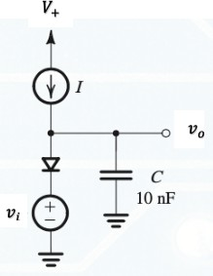
Forward Backward
Figure 1: Diode IV Circuit. Figure 2: DC diode Circuit. Figure 3: AC Diode Circuit

Procedure
Part (1): Diode IV Characteristics.
- Connect the circuit in figure 1 (Forward). Use the circuit elements values given by the lab instructor. 𝑉₊ is a DC voltage source.
- Use the DC Sweep function and simulate the response of the circuit to produce the IV curve
of the diode (𝐼_{𝐷} vs. 𝑉_{𝐷}). What is the 𝑉_{𝐷0} of this diode? Record the results in table 1.
- Repeat for the backward circuit. What is the 𝑉_{Z0} of this diode? Record the results in table 1.
- Vary the value of 𝑅 and repeat the procedure observing the effects (if any).
Part (2): DC Diode Circuit.
- Connect the circuit in figure 2. Use the circuit elements values given by the lab instructor. 𝑉₊
and 𝑉_{𝑖} are fixed DC voltage sources.
- Simulate the circuit. Which diode is ON and which is OFF?

- With 𝑉_{𝑖} fixed, vary the value of 𝑅 and repeat step 2 observing the effects on the diodes switching. Record your results in table 2.
Page11
- With 𝑅 fixed, vary 𝑉_{𝑖} between the range -10 to +10 V and plot the output characteristics curve (𝑉_{𝑜} vs. 𝑉_{𝑖}).
Part (3): AC Diode Circuit.
- Connect the circuit in figure 3. Use the circuit elements values given by the lab instructor. 𝐼 in the circuit is a DC current source and 𝑣_{𝑖} is a sinusoidal signal with small amplitude (less than 10 mV) and a frequency 𝑓.
- Simulate the circuit and plot the waveforms for 𝑣_{𝑖} and 𝑣_{𝑜} (versus time).
- From the plot in step 2, find the phase shift between 𝑣_{𝑖} and 𝑣_{𝑜}. Record the result in table 3.
- Vary 𝐼 and observe the phase shift between 𝑣_{𝑖} and 𝑣_{𝑜} at each setting. Record your results in table 3. Find a value of 𝐼 that gives a phase shift of ±45º?

Results and Analysis
Part (1): Diode IV Characteristics.

Table 1. Diode IV Curve.

𝑅 (kΩ) | Simulation  𝑉_{𝐷0} (V) | Data sheet  𝑉_{𝐷0} (V) | Simulation  𝑉_{Z0} (V) | Data sheet  𝑉_{Z0} (V)
- Comment on the results in table 1.

- Do the IV curves that you obtained resemble the standard diode characteristics? Explain.

Page12
Part (2): DC Diode Circuit.

Table 2. Simulated DC results.

𝑅 (kΩ) | Diode 1 (ON/OFF) | Diode 2 (ON/OFF) | 𝑉₀ (V)

- Comment on the results in table 2.

- Comment of the output characteristics curve.

Part (3): AC Diode Circuit.
Table 3. Simulated AC results.

I (mA) | Phase shift

- Which value of 𝐼 gives a phase shift of ±45º?
Page13

- Explain the output waveform.

- Comment on the circuit output characteristics curve.

Lab Assignment
Page14
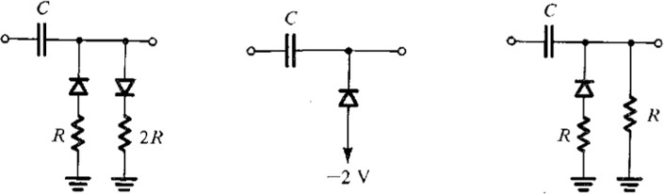

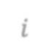





𝑣_{𝑖}
𝑣_{𝑜}
𝑣_{𝑖}
𝑣
𝑜
𝑣_{𝑖}
𝑣_{𝑜}

Circuit 1 Circuit 2 Circuit 3

- The lab instructor will assign one circuit to you with appropriate elements values. All diodes are 1N4001 model.
- Connect the circuit using the circuit elements values given by the lab instructor. 𝑣_{𝑖} is a periodic signal as shown below.
- Simulate the circuit observing the waveform at the output (𝑣_{𝑜}).
- By varying the amplitude of the input signal from 0 to 15 V, produce the transfer function curve of this circuit at the frequency given below.
- Fix the amplitude at the value below but vary the signal period from 0.1 to 10 ms and make observations regarding the circuit operation.
- Study the effect of the elements 𝑅 and 𝐶 (independently) on the operation of the circuit. Give conclusions.
- What application can this circuit be good for? Explain.

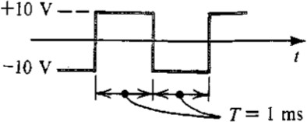
𝑣_{𝑖}

Name |  | Name |  | Name |  | Name
ID |  | ID |  | ID |  | ID
Section

Page15
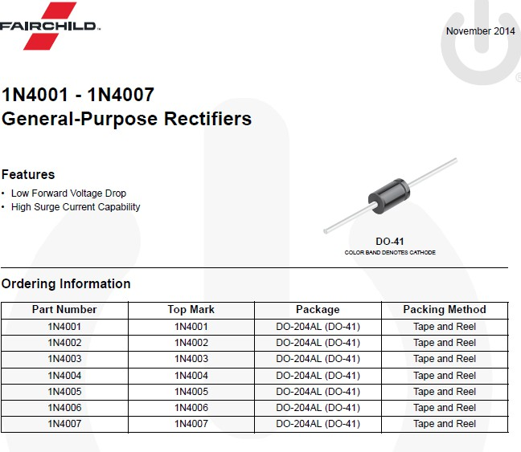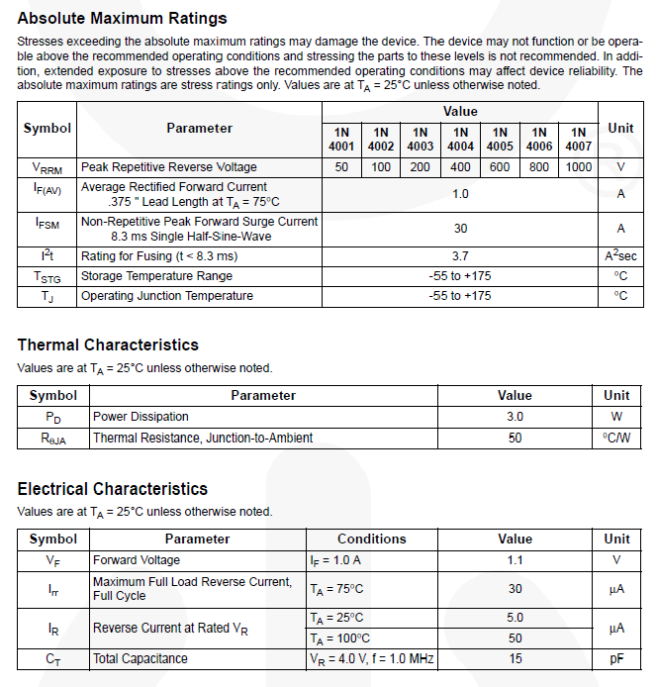

Objectives

Experiment (4) Diode Characteristics

  - To experimentally determine the IV characteristics of a general purpose diode.
Page16
  - To analyze a simple diode circuit using graphical methods.
  - To study the application of diodes in logic gate design.

Pre-lab Work
Analyze the two circuits using the constant voltage diode model (𝑉_{𝐷0}=0.7 V).

Solution
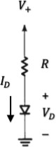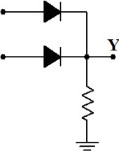
𝑅
+
𝑽_{𝑹}
_
𝑉_{𝐴}

𝑉_{𝐵}

Inputs
𝑉_{F}
Output
𝑅
Figure 1: Diode IV curve. Figure 2: A diode logic gate circuit.

Equipment
Table 1. Equipment for experiment 4.

 | Equipment | Model | Serial No. | Stock No.
1 | BreadBoard Station
2 | 1 kΩ Resistor (2W, 5%)
3 | Silicon Diodes (2) | 1N4001 | https://www.onsemi.com/pub/Collateral/1N4001-D.PDF
4 | Multi-meter (1)
5 | Probes and cables

Experimental Procedure
Part (1): Diode Forward IV Characteristics.
- Start first by checking if the diode is not damaged. Set the multimeter on resistance measurement. Touch the black lead (negative) of the multimeter to the cathode of the diode (refer to figure 3) and the red lead (positive) to the anode. In this configuration, the diode is forward-biased, and you should get a resistance reading between 1 kΩ and 10 MΩ. Next, switch the leads to the opposite terminals. The diode is now reverse-biased, and the reading should be infinity. If the readings are the same in both directions, the diode is damaged.

- Connect the circuit in figure 1, with 𝑅=1 kΩ. Pay a special attention to how you connect the two terminals of the diode by referring to figure 3.
Page17
- Starting with 0 volts, increase the DC voltage source 𝑉₊ in small steps (0.1 V, for example). In each setting, measure the voltage across the diode and across the resistor using the multi- meter. Enter your measurements in table 2.
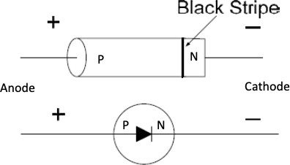
Figure 3: Diode marking.
Part (2): Graphical Analysis of Diode Circuits.
- Consider again the circuit in figure 1, with a 𝑅=1 kΩ. and 𝑉₊=2 V.
- Measure the voltages 𝑉_{𝐷} and 𝑉_{𝑅} using the multi-meter. Enter your measurements in table 3.
- With the diode removed from the circuit (open-circuit), measure the voltages 𝑉_{𝐷} and 𝑉_{𝑅}. Enter your measurements in table 3.
- With the diode shorted (a wire is placed instead), measure the voltages 𝑉_{𝐷} and 𝑉_{𝑅} using the multi-meter. Enter measurements in table 3.
Part (3): Diode Application as a Logical Gate.
- Connect the circuit shown in figure 2.
- Connect the inputs 𝑉_{𝐴} and 𝑉_{𝐵} to 0 volts or +5V (for a total of four combinations), as shown in table 5. In each combination, record the value of the output voltage 𝑉_{F} in table 5.

Results and Analysis

Part (1): Diode Forward IV Characteristics.
- Calculate the diode current (𝐼_{𝐷}) in table 2.
- Now, use the graphing space below to plot the diode characteristics 𝐼_{𝐷} (vertical axis) versus
𝑉_{𝑅} (horizontal axis). Appropriately label your plot.
- Does the curve resemble the usual diode IV curve? Explain any discrepancies. Answer:

Page18

Table 2. Measurements for Part (1).

DC Input 𝑉₁ (V) | 𝑉_{𝐷} (V) | 𝑉_{𝑅} (V) | 𝐼_{𝐷}= 𝑉_{𝑅}/𝑅 (mA)

Graph 1: Diode IV characteristics.

Part (2): Graphical Analysis of Diode Circuits.
- Calculate the diode current (𝐼_{𝐷}) in table 3 for all three cases.
- Now, on the same graphing space above (graph 1), draw the “load line” of the circuit. Use the second and third entries in table 3.
- The intersection point between the load line and the diode characteristics curve is the “operating point” of the circuit. Find this point from the graph and record it in table 4.
- Also, record in table 4 the experimental current value (table 3, first entry) and the theoretical current value (from pre-lab calculations).
- Calculate the percent differences. Which value do you think is more accurate? Explain.

Page19
Answer:

Table 3. Measurements for Part (2).

Diode | 𝑉_{𝐷} (V) | 𝑉_{𝑅} (V) | 𝐼_{𝐷}= 𝑉_{𝑅}/𝑅 (mA)
Included
Removed
Shorted

Table 4. Calculations for Part (2).

𝐼_{𝐷} (mA) Experimental value | 𝐼_{𝐷} (mA) Graphical value | %  Difference | 𝐼_{𝐷} (mA) Theoretical value | %  Difference

Part (3): Diode Application as a Logical Gate.
- From the results in table 5, what logic function does the circuit perform?
- Diodes are not commonly used in the design of logic gate. Investigate and explain why not? Answer:

Table 5. Measurements for Part (3).

𝑉_{𝐴} (V) | 𝑉_{𝐵} (V) | 𝑉_{F} (V)
0 | 0
0 | 5
5 | 0
5 | 5

Page20

LTspice Simulations
Include with your report LTspice simulation results of all parts of this experiment.

Conclusions and Remarks
Write below all your conclusions/remarks on this experiment.

Name |  | Name |  | Name
ID |  | ID |  | ID
Section

Page21
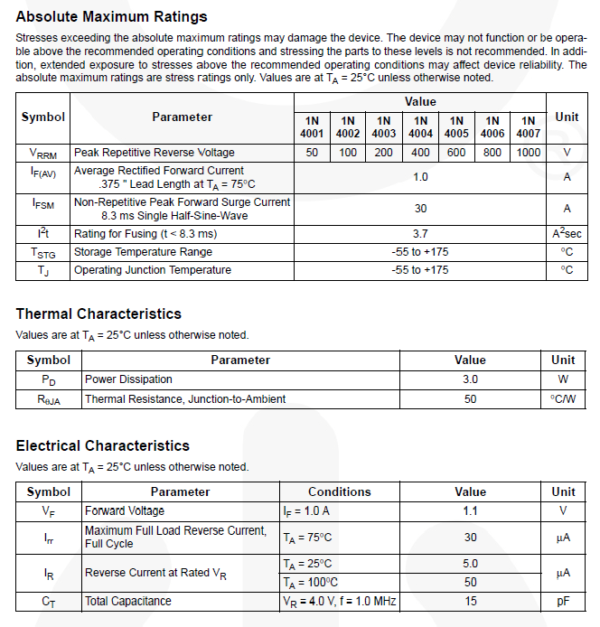

Objectives

Experiment (5)
Diode Rectifier with Peak Detector

- To study the half-wave rectifier function.
Page22
- To analyze the output of a peak detector with regulator.

Pre-lab Work
Analyze the circuit below using the constant voltage diode model. The input is a sinusoidal wave with amplitude 𝑉_{𝑚} and frequency 𝑓. Find 𝑉_{𝑜} with and without the capacitor and the Zener diode. In each case, draw the waveform of the output and find the average output voltage and average load current.
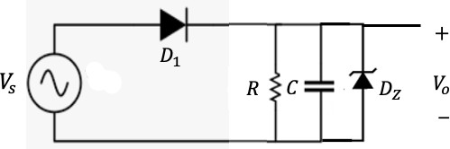
Solution

Figure 1: Half-wave rectifier with peak detector and regulator.

Equipment
Table 1. Equipment for experiment 5.

 | Equipment | Model | Serial No. | Stock No.
1 | BreadBoard Station
2 | 1 kΩ Resistor (2W, 5%)
3 | Capacitors (2)
4 | Diodes (2) | 1N4001 (1) 1N4732 (1)
5 | Multi-meter (1)
6 | Dual-trace Oscilloscope
7 | Probes and Cables

Experimental Procedure
Part (1): Half-wave Rectifier Output Analysis.
- Connect the circuit in figure 1 without the capacitor and the Zener diode and with 𝑅=1 kΩ. Pay a special attention to how you connect the terminals of the diode. The input voltage source
𝑉_{𝑆} is sinusoidal.
- Connect channel 1 of the oscilloscope to 𝑉_{𝑆} and adjust it to 10 V amplitude at 60 Hz. Pay attention to the polarity of the oscilloscope connection. Sketch the input waveform in graph 1 labeling all important points in both voltage and time axes. Make your sketch as accurate as possible.

- Now connect channel 2 of the oscilloscope to 𝑉₀. Sketch the output waveform on the same graph 1 labeling all important points in both voltage and time axes. Make your sketch as accurate as possible. Use different colors for the waveforms.
Page23
- Using the multi-meter, measure the output voltage and record it in table 2. Part (2): Half-wave Rectifier with Peak Detector and Regulator.
- Consider again the circuit in figure 1 with only the capacitor connected.
- Repeat the whole procedure in part 1 for both capacitors provided. Record results in graph 1 and table 3. Use different colors for the waveforms.
- Finally, connect the Zener diode across the capacitor and observe the output. Record results in graph 1. Use different colors for the waveforms.

Results and Analysis
Part (1): Half-wave Rectifier Output Analysis.

Graph 1: Sinusoidal input case.

Table 2. Average output voltage of the half-wave rectifier without peak detector.

Sinusoidal input
𝑉# (ave) (V) Experimental value | 𝑉# (ave) (V) Theoretical value | %  Difference

Page24

- Calculate the theoretical value of the average output voltage and record it in table 2.
- Comment on your results regarding the waveforms in graph 1.

- Comment on your results regarding the average output voltage.

Part (2): Half-wave Rectifier with Peak Detector and Regulator.

Table 3. Average output voltage of the half-wave rectifier with peak detector.

 | Sinusoidal input
Capacitor value (µF) | 𝑉# (ave) (V) Experimental value | 𝑉# (ave) (V) Theoretical value | %  Difference

- Calculate the theoretical value of the average output voltage and record it in table 3.
- Comment on your results regarding the waveforms in graph 1.

- Comment on your results regarding the average output voltage
Page25

LTspice Simulations
Include with your report LTspice simulation results of all parts of this experiment.

Conclusions and Remarks
Write below all your conclusions/remarks on this experiment.

Name |  | Name |  | Name |  | Name
ID |  | ID |  | ID |  | ID
Section

Objectives

Experiment (6) MOSFET IV Characteristics

- To study the IV curve of a MOSFET.
Page26
- To graphically find the operating point of a MOSFET circuit.

Pre-lab Work
Analyze the DC circuit below. Assume the transistor is in saturation and find expressions for the drain current and the drain-source voltage. Ignore channel length modulation.

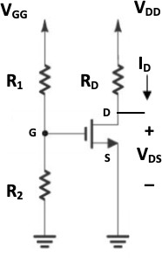
Solution

Figure 1: A MOSFET DC Circuit.

Equipment
Table 1. Equipment for experiment 6.

 | Equipment | Model | Serial No. | Stock No.
1 | BreadBoard Station
2 | Resistors 1 kΩ (1), 1 MΩ (2)
3 | NMOS transistor (1) | 2N7000 | https://www.onsemi.com/pub/Collateral/2N7000-D.PDF
4 | Multi-meter (1)
5 | Probes and cables

Experimental Procedure
Part (1): MOSFET IV Characteristics.
- Connect the circuit in figure 1 with 𝑅_{𝐷}=1 kΩ and 𝑅₁= 𝑅₂=1 MΩ. Pay a special attention to how you connect the terminals of the MOSFET (refer to the data sheet to identify the transistor terminals).
- Set 𝑉_{𝐺𝐺} to a constant voltage of +8 V while connecting 𝑉_{𝐷𝐷} to a variable DC voltage source.

- The IV characteristics (𝐼_{𝐷} versus 𝑉_{𝐷𝑆}) is obtained by gradually varying 𝑉_{𝐷𝐷} (from 0 to +10 V) and measuring the voltage 𝑉_{𝐷𝑆} and 𝑉_{𝑅}𝐷 at each setting. Use table 2 to enter your results.
Page27
- Repeat step 3 for another value of 𝑉_{𝐺𝐺}, say +10 V. Record your results in table 2.
Part (2): Graphical Analysis of a DC MOSFET Circuit.
- Reconsider the circuit in figure 1, with 𝑉_{𝐺𝐺} = 𝑉_{𝐷𝐷} = +10 𝑉. Measure 𝑉_{𝐷𝑆} and record the results in table 3. Note that 𝐼_{𝐷} = (𝑉_{𝐷𝐷} − 𝑉_{𝐷𝑆})/𝑅_{𝐷}. This is the operating point of this circuit.

Results and Analysis
Part (1): MOSFET IV Characteristics.
- Calculate 𝑉_{𝐺𝑆} (using voltage divider rule) and the current 𝐼_{𝐷} (𝑉_{𝑅}𝐷/𝑅_{𝐷}) in table 2, for both values of 𝑉_{𝐺𝐺}.
- Use graph 1 to sketch the IV curves (𝐼_{𝐷} versus 𝑉_{𝐷𝑆}) for the two 𝑉_{𝐺𝑆} values using the results in table 2.

Table 2. IV Characteristics Measurements.

 | 𝑉_{𝐺𝐺} = 8V, 𝑉_{𝐺𝑆} = |  |  | 𝑉_{𝐺𝐺} = 10V, 𝑉_{𝐺𝑆} =
𝑉_{𝐷𝐷} (V) | 𝑉_{𝐷𝑆} (V) | 𝑉_{𝑅}𝐷 (V) | 𝐼_{𝐷} (mA) | 𝑉_{𝐷𝑆} (V) | 𝑉_{𝑅}𝐷 (V) | 𝐼_{𝐷} (mA)
0.0
1.0
2.0
3.0
4.0
5.0
6.0
7.0
8.0
9.0
10.0

Graph 1: MOSFET IV Curves.

- Comment on the IV curves that you obtained. Can you identify the transistor modes of operation?
Answer:

- Is the drain current constant in the saturation region of the IV curve? Explain why or why not.
Answer:

Part (2): Graphical Analysis of a DC MOSFET Circuit.
- The load line equation for this circuit is 𝐼_{𝐷} = ^{𝑉𝐷𝐷–𝑉𝐷𝑆}. It is the line connecting the two points
𝑅
𝐷
(0,^{𝑉𝐷𝐷}) and (𝑉 ,0) on the IV curve.

𝑅𝐷
𝐷𝐷

- Draw the load line on top of the IV curves in graph 1. Mark the intersection point of the curves.
Page28
- The intersection of the load line and the IV curve gives the operating point of the circuit. Read the drain current (𝐼_{𝐷}) value and the drain-source voltage (𝑉_{𝐷𝑆}) value from the intersection point in graph 1. Record the results in table 3.
- The experimental value of 𝐼_{𝐷} = (𝑉_{𝐷𝐷} − 𝑉_{𝐷𝑆})/𝑅_{𝐷}.

Page29
Table 3. Graphical Solution Results.

𝑉_{𝐷𝐷}= 10 V and 𝑉_{𝐺𝐺} = 10 V
𝑉_{𝐷𝑆} (V) Experimental value | 𝑉_{𝐷𝑆} (V) Graphical value | %  Difference | 𝐼_{𝐷} (mA) Experimental value | 𝐼_{𝐷} (mA) Graphical value | %  Difference

- Comment on your results explaining the sources of differences.
Answers:

LTspice Simulations
Include with your report LTspice simulation results of all parts of this experiment.

Conclusions and Remarks
Write below all your conclusions/remarks on this experiment.

Name |  | Name |  | Name |  | Name
ID |  | ID |  | ID |  | ID
Section

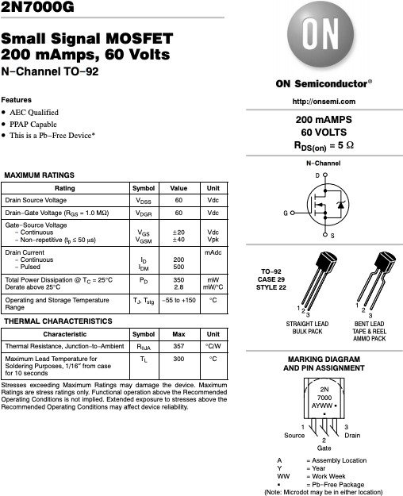
Page30

Objectives

Experiment (7)
The Common-source Amplifier

- To study the operation of a common-source amplifier.
Page31
- To verify the voltage gain relations of the common-source amplifier.

Pre-lab Work
Find general expressions for the voltage gain, input resistance and output resistance of the common- source amplifier circuit in figure 1.
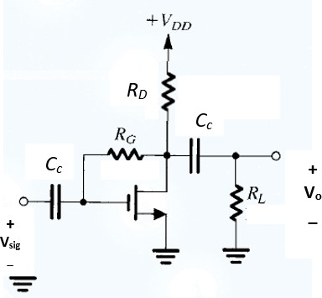
Solution
𝑣_{𝑜}
𝑣𝑠𝑖*

Figure 1: A Common-source Amplifier Circuit.

Equipment
Table 1. Equipment for experiment 7.

 | Equipment | Model | Serial No. | S No.
1 | BreadBoard Station
2 | Resistors 10 kΩ (2), 100 kΩ (1),  1 MΩ (1)
3 | NMOS transistor (1) | 2N7000 | https://www.onsemi.com/pub/Collateral/2N7000-D.PDF
4 | Capacitors 22 µF (2)
5 | Multi-meter (1)
6 | Probes and cables

Experimental Procedure
Part (1): Amplifier Voltage Gain.
- Connect the circuit in figure 1 without the ac source, capacitors and the load resistor. Take
𝑉_{𝐷𝐷}=10 V, 𝑅_{𝐷}=10 kΩ and 𝑅_{𝐺}=1 MΩ.

- Measure the DC voltages at the drain and at the gate. Measure the voltage across 𝑅_{𝐷} to find

the DC drain current (Use 𝐼_{𝐷}
= 𝑉𝑅𝐷). Make sure the transistor is operating in saturation mode.
𝐷
𝑅

- Now add the capacitors and the load resistor (𝑅_{𝐿}=10 kΩ) and connect a sinusoidal ac source
Page32
𝑣_{𝑠𝑖9}. Start with a small amplitude (in mV) at 10 kHz for 𝑣_{𝑠𝑖9}.
- Connect both the input signal and the output terminals to the oscilloscope using two channels.
- Observe both waveforms simultaneously and produce a sketch using graph 1.
- Increase the amplitude of 𝑣_{𝑠𝑖9} in steps of a few mV. In each case record the amplitudes of 𝑣_{𝑠𝑖9}
and 𝑣_{𝑜} in table 2.
- Continue until you notice that the output becomes distorted. Mark the maximum input and output before distortion.
Part (2): Input and Output Resistance of Amplifier.
- Reconsider the circuit in figure 1. Set the input signal at a comfortable value within the linear range of the amplifier.
- To find the output resistance of the amplifier, measure the voltage gain with and without the load resistor. Record results in table 3.
- To find the input resistance, connect a resistor (𝑅_{𝑥}=100 kΩ) between the input voltage source and the coupling capacitor (in series). Measure the voltage gain with and without 𝑅_{𝑥}. Record results in table 3.

Results and Analysis
Part (1): Amplifier Voltage Gain.
- Calculate the voltage gain of this amplifier (𝑣_{𝑜}/𝑣_{𝑠𝑖9}) and record your results in table 2.
- Comment on the linearity of the amplifier in this circuit. Answer:

- What is the maximum output swing for this set-up of the amplifier? Explain. Answer:

Page33

Graph 1: Amplifier input/output waveforms.

Table 2. Voltage Gain Results

Amplitudes
𝑣_{𝑠𝑖9} (mV) | 𝑣_{𝑜} (mV) | Gain

Part (2): Input and Output Resistance of Amplifier.
- Calculate the input and output resistances of this amplifier circuit and record them in table 3.
Table 3. Input/output Resistances.

Output Resistance (kΩ) |  |  | Input Resistance (kΩ)
Gain with 𝑅_{𝐿} | Gain without 𝑅_{𝐿} | 𝑅_{𝑜} | Gain with 𝑅_{𝑥} | Gain without 𝑅_{𝑥} | 𝑅_{𝑖}

- Comment on your results based on your knowledge of the properties of the common-source amplifier.
Page34
Answer:

LTspice Simulations
Include with your report LTspice simulation results of all parts of this experiment.

Conclusions and Remarks
Write below all your conclusions/remarks on this experiment.

Name |  | Name |  | Name |  | Name
ID |  | ID |  | ID |  | ID
Section

Objectives

Experiment (8) BJT IV Characteristics

- To study the IV curve of a BJT.
Page35
- To experimentally evaluate the DC gain parameter of a BJT.
- To study the transfer function of a BJT circuit.

Pre-lab Work
Analyze the DC circuit below. Assume the transistor is in active mode and find expressions for the collector current and the collector-emitter voltage.
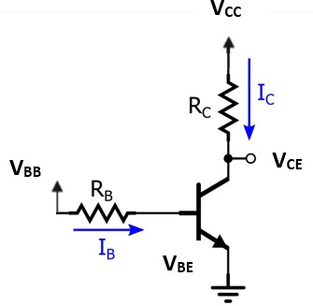
Solution
𝑪
𝑩
𝑬
Figure 1: A BJT DC Circuit.
𝐼_{𝐵}
𝐼_{𝐶}

Equipment
Table 1. Equipment for experiment 8.

 | Equipment | Model | Serial No. | Stock No.
1 | BreadBoard Station
2 | Resistors 5 kΩ (1), 10 kΩ (1),  100 kΩ (1)
3 | BJT NPN transistor (1) | 2N3904 | https://www.onsemi.com/pub/Collateral/2N3903-D.PDF
4 | Multi-meter (1)
5 | Probes and cables

Experimental Procedure
Part (1): BJT IV Characteristics
- Connect the circuit in figure 1 with 𝑅_{𝐶}=10 kΩ and 𝑅_{𝐵}=100 kΩ. Pay a special attention to how you connect the terminals of the BJT. Refer to the data sheet to identify the transistor terminals.

- Set 𝑉_{𝐵𝐵} to a constant voltage of +10 V while connecting 𝑉_{𝐶𝐶} to a variable DC voltage source.
Page36
- The IV characteristics (𝐼_{𝐶} versus 𝑉_{𝐶𝐸}) is obtained by slowly varying 𝑉_{𝐶𝐶} and measuring the voltage 𝑉_{𝐶𝐸} and 𝑉_{𝑅}C at each setting. Use table 2 to enter your results. Also record the measured values of 𝑉_{𝑅}𝐵 at each setting (to be used in part 2 of the experiment).
Part (2): BJT DC Gain Parameter (𝛽)
- The required data have been collected in part 1.
Part (3): BJT Transfer Function
- Reconsider the circuit in figure 1.
- Set 𝑉_{𝐶𝐶} to a constant voltage of +10 V while connecting 𝑉_{𝐵𝐵} to a variable DC voltage source.
- The transfer function (𝑉_{𝐶𝐸} versus 𝑉_{𝐵𝐵}) is obtained by slowly varying 𝑉_{𝐵𝐵} and measuring the voltage 𝑉_{𝐶𝐸} at each setting. Use table 3 to enter your results.
- Repeat step 3 for another value of 𝑅_{𝐶}, say 5 kΩ. Record your results in table 3.

Results and Analysis
Part (1): BJT IV Characteristics.
- Calculate the currents 𝐼_{𝐶} and 𝐼_{𝐵} values in table 2 (Use 𝐼_{𝐶} = 𝑉_{𝑅𝐶}/𝑅_{𝐶} and 𝐼_{𝐵} = 𝑉_{𝑅𝐵}/𝑅_{𝐵}).
- Use graph 1 to sketch the IV curve.

Table 2. IV Characteristics Measurements.

𝑉_{𝐶𝐶} (V) | 𝑉_{𝐶𝐸} (V) | 𝑉_{𝑅}C (V) | 𝐼_{𝐶} (mA) | 𝑉_{𝑅}𝐵 (V) | 𝐼_{𝐵} (mA) | 𝛽 = 𝐼_{𝐶}/𝐼_{𝐵}
0.0

- Comment on the IV curve that you obtained. Can you identify the transistor modes of operation? Show your answer on the curve.
Page37
Answer:

- Is the collector current constant in the active mode region of the IV curve? Find an approximate value of the Early voltage.
Answer:

Graph 1: Transistor IV Curve.

Part (2): BJT DC Gain Parameter (𝛽)
  - Calculate the current 𝐼_{𝐵} values in table 2. Also, calculate the DC gain parameter (𝛽).
  - Why is the value of 𝛽 not constant in the table? Explain in details. Answer:

  - Use graph 2 to sketch 𝛽 vs. 𝐼_{𝐶} relation. Compare to the curve given in the transistor data sheet and give your comments.
Page38
Answer:

Graph 2: DC gain parameter.
Part (3): BJT Transfer Function
- Use graph 3 to sketch the two transfer functions using the data in table 3, for both 𝑅_{𝐶} values.
- Can you identify the transistor modes of operation? Show your answer on the curves. Answer:

Table 3. Transfer Function Measurements.

 | 𝑅_{𝐶}= 10 kΩ | 𝑅_{𝐶}= 5 kΩ
𝑉_{𝐵𝐵} (V) | 𝑉_{𝐶𝐸} (V) | 𝑉_{𝐶𝐸} (V)
0.0

Page39

Graph 3: Circuit transfer function.
- Comment on the general shape of the transfer function. In particular, explain the main differences between the two curves, in relation to 𝑅_{𝐶} value.
Answer:

Page40

LTspice Simulations
Include with your report LTspice simulation results of all parts of this experiment.

Conclusions and Remarks
Write below all your conclusions/remarks on this experiment.

Name |  | Name |  | Name |  | Name
ID |  | ID |  | ID |  | ID
Section

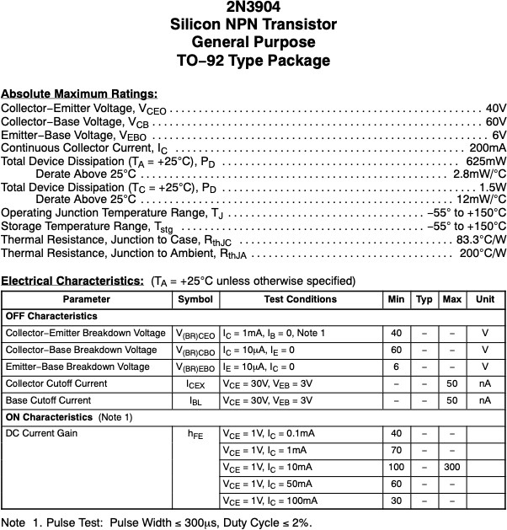
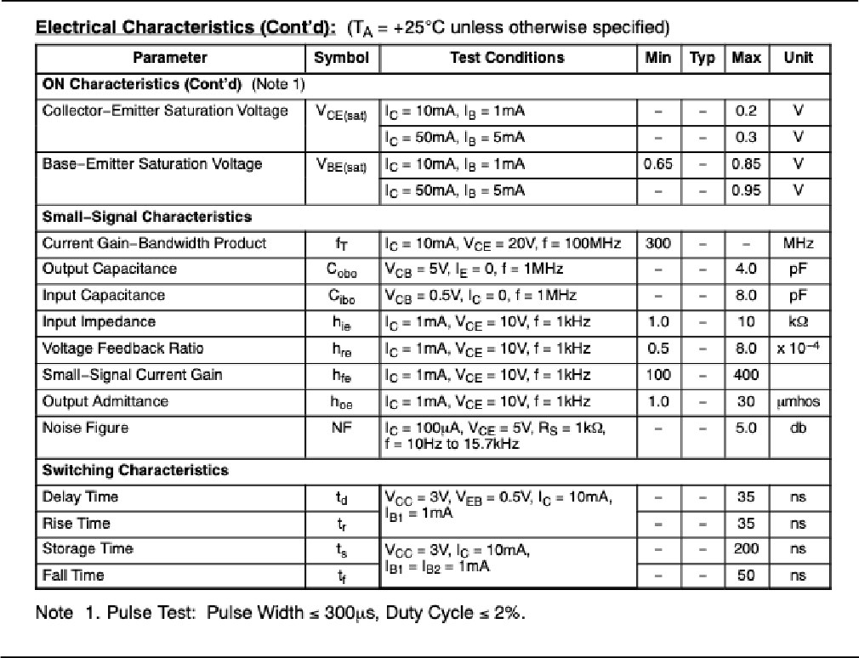
Page41

COMMENTS AND REMARKS ON THE LAB MANUAL
Page42

